**Predicting the impact of an oil or gas discovery on the future GDP growth of a country: Example of Guyana**

## **I) Introduction**

The impact of oil discoveries can be significant on the economy of a country. During the industrialization of the 20th century several major oil discoveries have shaped the economies of entire regions, and tremendous amount of economic growth was generated as result, changing the livelihood of millions of people around the world. The most well know oil regions are in the Middle East, Russia, Central Asia, North Africa and Latin America. The economies of oil exporting countries and their GDP have become heavily dependent on the export of its precious crude and its derivatives since the second half of the 20th centuries.

## **II) Problematic**

In 2015 Guyana, a small country in northern part of South America, made a significant oil discovery that is estimated to about 8 billion barrels. The country's population is less than a million and the main economy was based on agriculture, fishing and mining. The oil discovery made by Exxon Mobil and its partners in the Stabroek block offshore is poised to change the economy and the GDP of the country. A CNBC article dated from Nov 9th, 2019 mentions that the IMF estimates that Guyana will see an 86% of annual economic growth in 2020 as a result of production. Although that number is quoted to be ambitious given the current political and financial contexts. On the other hand, IHS Markit predicts a more reasonable 30% GDP growth for 2020. So how can one quantify the impact of this discovery on the country's GDP over the next few years? And which of the two estimates would be more likely?

## **III) Dataset**

### Economic Indicators from the World Bank database

#### a) Fuel Exports (%)

Fuel exports tables will help select countries whose economy and GDP rely primarily (>75%) on income from exporting oil and its derivatives. We selected the countries where fuel exports represent more than three quarters of their total exports. The data is sparse at times for certain countries but overall this is a good representation of these countries’ dependence to oil as a source of income. The total number of countries is 30.

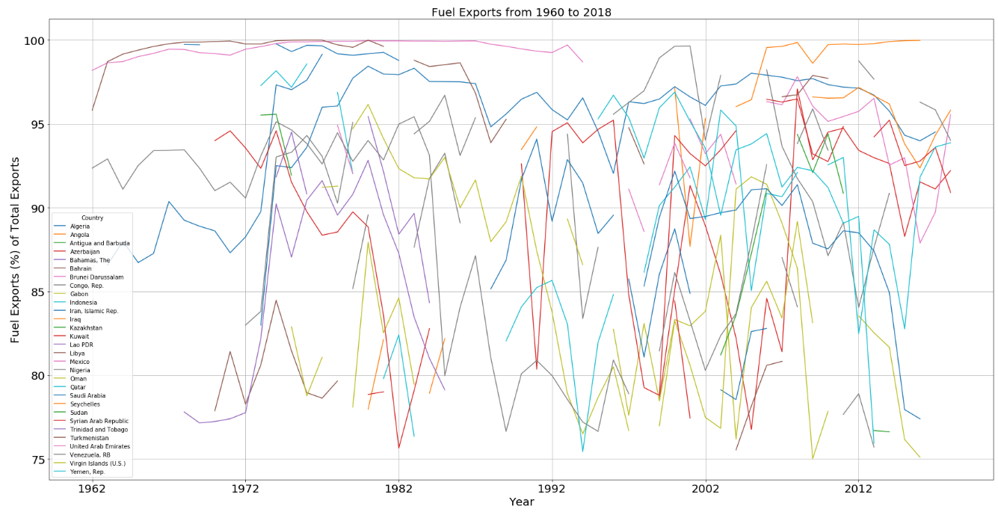

#### b) GDP Growth

The second indicator we obtained was GDP growth (%) data from the World Bank for 24 major oil exporting countries from 1960 to 2018.

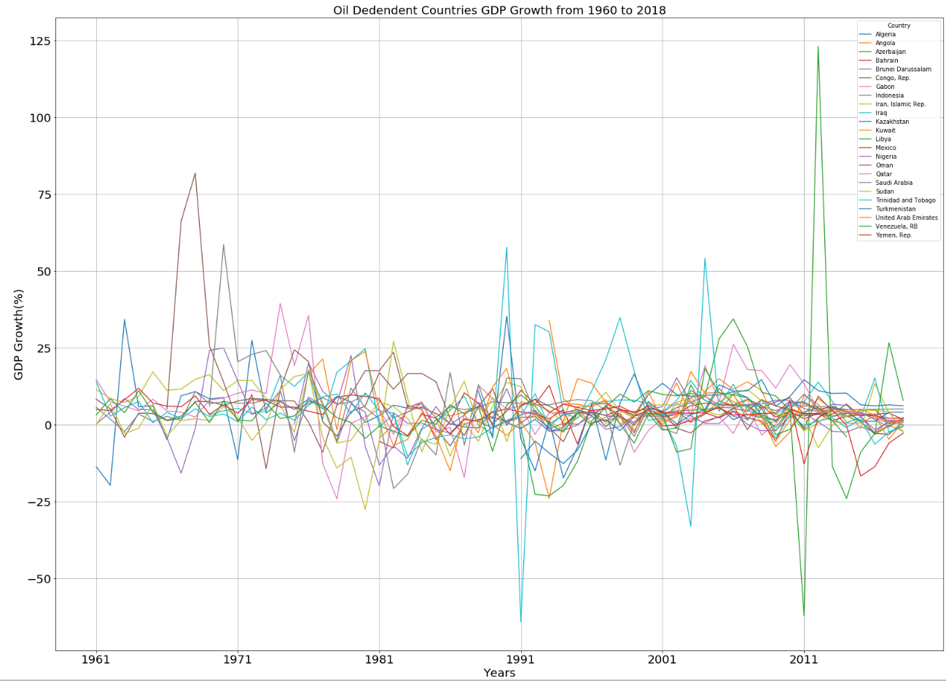

#### c) GDP Growth per Capita

The last indicator we obtained was GDP growth per capita (%) from the World Bank for 24 major oil exporting countries from 1960 to 2018.

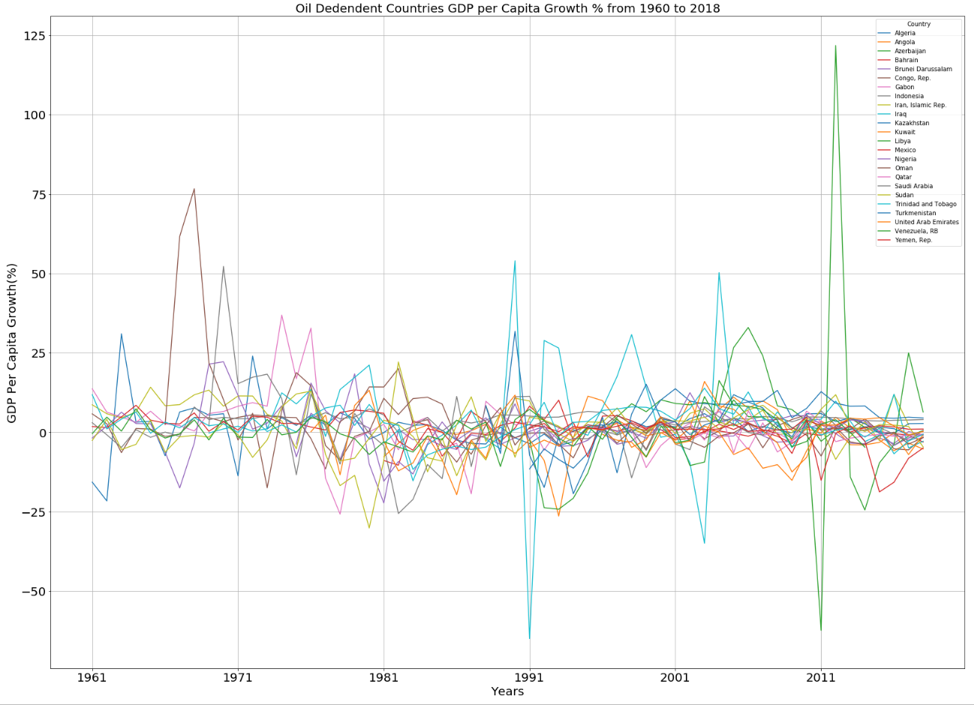

1. Oil and Gas Discoveries

We downloaded the data that contains all oil and gas field discovered from 1868 to 2010 from a Harvard study. From a total of 995 total discoveries 745 were made between 1960 and 2010, which coincides with the time frame of the World Banks dataset.

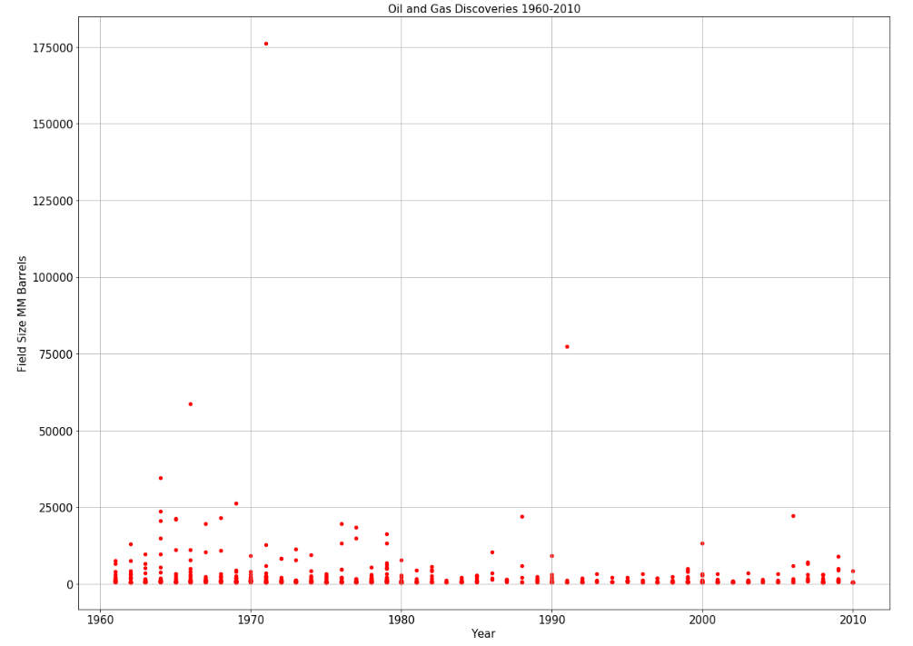

Largest 20 fields discovered from 1960-2010

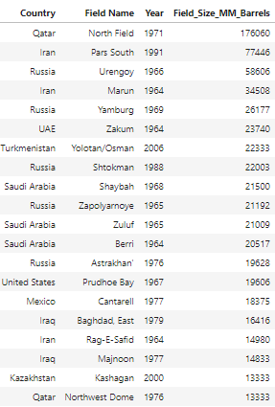 

## **IV) Data Exploration**

I started to ask how the size of a discovery would impact GDP growth. I tried to establish a relationship between GDP growth and field size. Unfortunately, the correlation between the two parameters was poor (0.1).

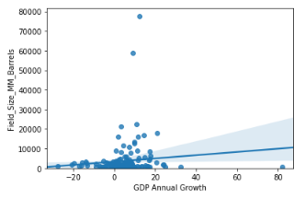

To better constrain the parameters, I took away the two very large discoveries that you can see on the previous plot. Although there was an improvement in the correlation factor (0.18), I concluded that it was still poor.

I then tried a different approach, perhaps less quantitative. I first looked at 3 examples of countries and plotted their GDP annual growth and field discovery size. I observed how GDP growth evolved following a discovery. Here is the example of Venezuela:

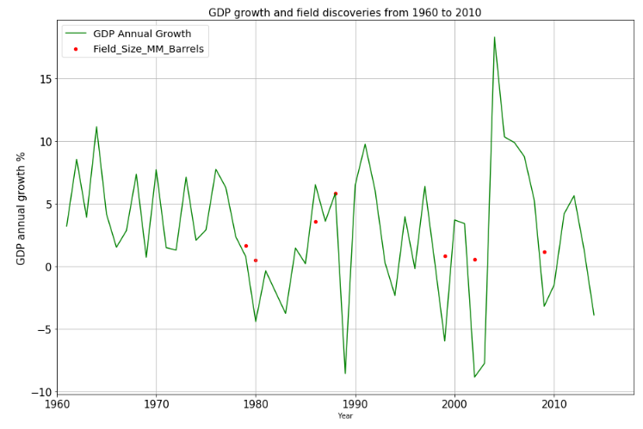

Notice the large GDP growth within 5 years following a discovery. Similar observations can be made on the Algeria and Iran plot (see github link).

Based on the assumption that the effect of a discovery on GDP will be noticed after un certain time period, in this case we assumed 5 years, I calculated the maximum GDP value in the data within 5 years that follow a discovery and plotted the result as follow:

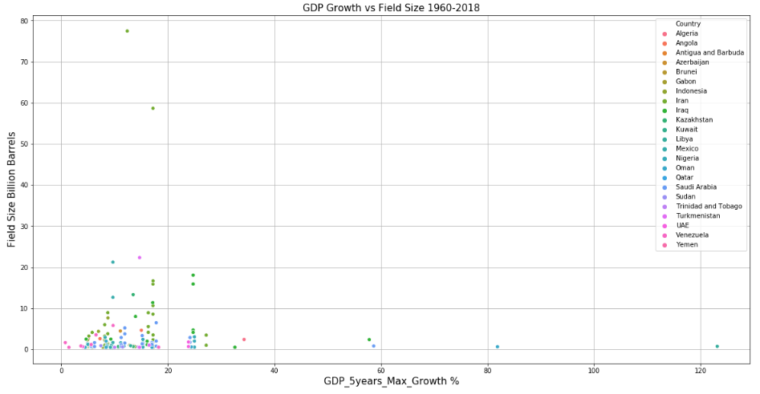

|  |
| --- |
| **Field_Size_B_Barrels** **GDP_Max_5Year_Growth**  count 212.000000 954.000000  mean 4.670425 11.672086  std 14.198313 12.550813  min 0.500000 -5.300000  25% 0.761000 5.740646  50% 1.358000 8.220007  75% 3.249250 13.533277  Max 176.060000 123.139555 |

To consider the size of population I used the same approach to calculate and plot the maximum GDP per capita growth within 5 years that follow a discovery. The results are plotted below:

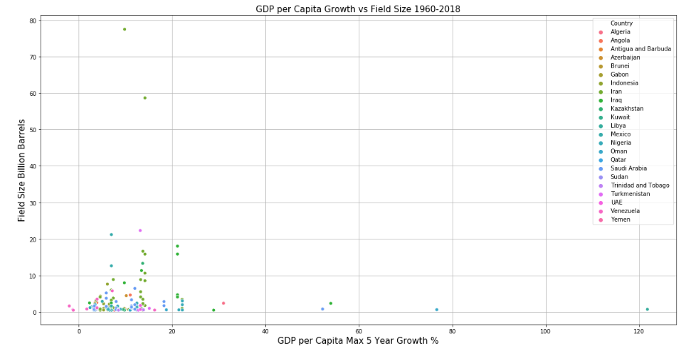

|  |
| --- |
| **Field_Size_B_Barrels** **GDP_per_Capita_Max_5 Year_Growth**  count 212.000000 951.000000  mean 4.670425 8.805936  std 14.198313 12.288241  min 0.500000 -7.011835  25% 0.761000 3.233565  50% 1.358000 5.579122  75% 3.249250 11.004097  max 176.060000 121.779543 |

There are a few (interesting) GDP growth outliers in this plot, which we plotted below:

|  |
| --- |
| **Country**  **Year**  **GDP Per Capita Annual Growth**  8091 Iraq 1990 53.974878  8105 Iraq 2004 50.236499  9331 Libya 2012 121.779543  11316 Oman 1967 61.658165  11317 Oman 1968 76.673873  12363 Saudi Arabia 1970 52.219090 |

## **V) Discussion and Conclusion**

The analysis conducted on the dataset from the World Bank and field discoveries from the Harvard study showed some interesting results.

First, we did not find a correlation between discovery size and GDP growth. Some of the largest fields discovered in the last 50 years resulted in 10-15% maximum GDP growth, whereas significantly smaller discoveries had similar GDP growth or more over the 5-year period following their discovery. Second, most of the highest GDP growth values observed for the same period are between 0-20%. Fewer countries experienced growth between 20-30% following a discovery and only a handful saw growth between 30-40%. Finally, only 4 countries recorded more than 40% GDP growth in one or two years. Those represented a recovery from major geopolitical event or crisis, civil war or military invasion, for example the two Iraq military invasions (1990 and 2003) or the fall of Gaddafi in Libya (2011).

Based on these results it is difficult to imagine that the GDP growth of Guyana after brining the Stabroek discovery would be 86% in 2020, as this level of growth was historically relative to a recovery from major crisis. The IHS market prediction of GDP growth at 30% seems more plausible, although our analysis would suggest a rate between 15and 25% to be more in line with historical records of GDP growth observed in 24 oil income dependent countries over the last 50 years. This analysis did not consider economic or political factors, nor any local conditions or context specific to Guyana that could still influence the estimation of the country's economic growth.

Additional Information and Code:

<https://gist.github.com/0d1236ac9c356cd6b3bb3922c793b856>